3. ☼ Tokenize and tag the following sentence: They wind back the clock, while we chase after the wind. What different pronunciations and parts of speech are involved?

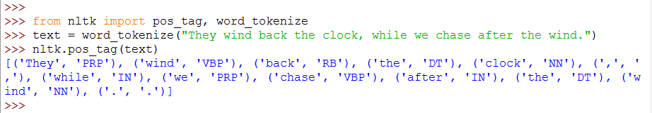

They are 2 different pronunciations for “wind”, a verb and a noun. “They” and “we” are pronouns (PRP), “wind” and “chase” are verbs (VBP), “back” is adverb (RB), “the” is determiner (DT), “clock” and “wind” are nouns (NN), “while” and “after” are conjunction/preposition.

5. ☼ Using the Python interpreter in interactive mode, experiment with the dictionary examples in this chapter. Create a dictionary d, and add some entries. What happens if you try to access a non-existent entry, e.g. d['xyz']?

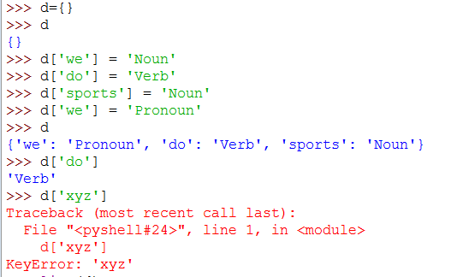

6. ☼ Try deleting an element from a dictionary d, using the syntax del d['abc']. Check that the item was deleted.

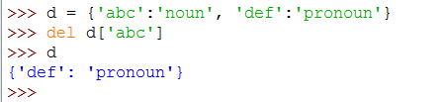

7. ☼ Create two dictionaries, d1 and d2, and add some entries to each. Now issue the command d1.update(d2). What did this do? What might it be useful for?

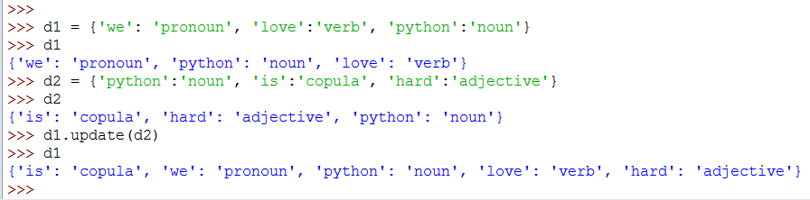

The update method adds all the items from d2 to d1. It can be used to add multiple keys with the same value.

10. ☼ Train a unigram tagger and run it on some new text. Observe that some words are not assigned a tag. Why not?

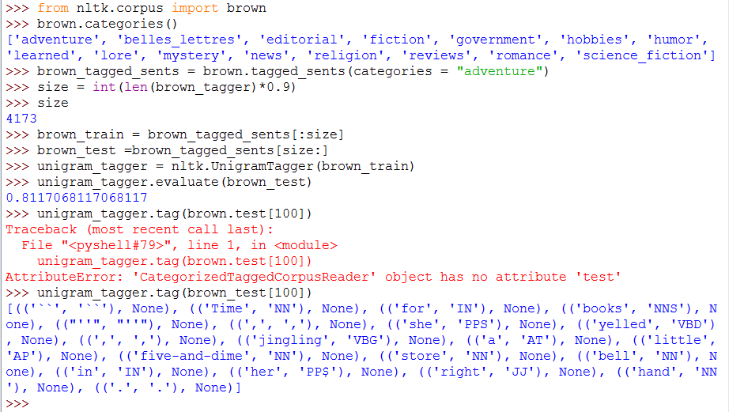

Many words have been assigned “None” because they are not among the words in the texts of “adventure” category.